(Press release for album announcement for usage in international press)
The extreme metal band BLODTØRST
to release third album “Nidviser”
New album Nidviser out September 18TH 2026.
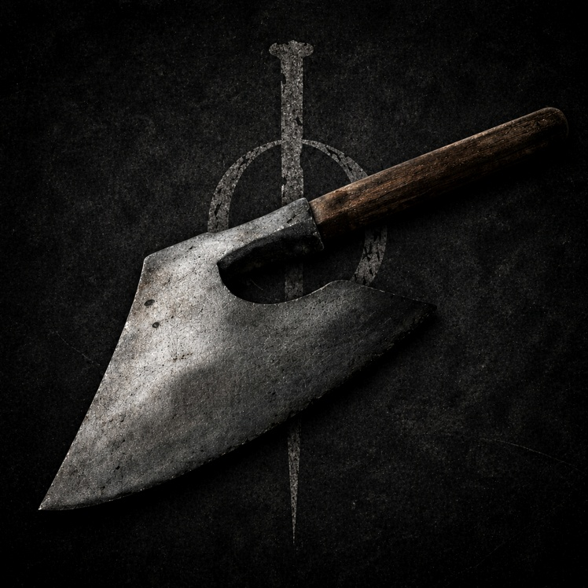
(Artwork: Blodtørst)
The Norwegian extreme metal band Blodtørst are gearing up to release their long anticipated third full length album “Nidviser” September 18th 2026.
Two singles have been released on streaming services to give an inkling on where the band is heading next after their second release “Dalmunr”.
Like its predecessor, Nidviser focuses on storytelling. But where Dalmunr was a concept album set to one fictional tale, Nidviser tells 12 different stories centered around one common theme. This time, all the songs are inspired by 18th century capital punishments in Norway. The musical vision is to show more of Blodtørst’s metal spectrum by balancing the bleak and cold aggressiveness with primal brutality.
The album is recorded, mixed and mastered in Grimsland Studios in Trondheim and will be released independently by the band.
The band celebrates the release of the album with a release concert in their hometown Trondheim at Lager 11 October (?) with special guests (?) and (?).
Blodtørst Discography
Nidviser (LP) - 2026
Dalmunr (EP) – 2023
Ferd (LP) – 2021
Haunted By Silhouettes lineup
Mathias Jamtli Rye (vocals), Andreas Almvik Johnsen (guitar), Arild Nilstad (guitar), Raymond Hansen (bass), Mads Aas (drums)
Media
(Dropbox folder) (
Social Media Tags (kindly use these tags)
- Tag on Facebook - @Blodtørst
- Tag on Instagram - @Blodtorstband
Contact:
blodtorstband@gmail.com

